Account Registration Instructions
For Responsible Officials

Iowa Department of Natural Resources
Wallace State Office Building
Air Quality Bureau
502 E 9th St
Des Moines, IA 50319
Phone: (515) 725-8200

Contact the Iowa EASY Air Helpdesk
email: easyair@dnr.iowa.gov
Or call (515) 725-9569 or (515) 204-3749

Table of Contents

1. Iowa EASY Air Website Login 3
2. Self-Registration 4
2.1 Fill in General Information 4
2.2 Indicate Account Type 5
2.3 Associate Facility or Facilities 6
2.4 Select and answer Security Questions 9
2.5 Pass Picture Verification 9
2.6 Select Identify Proofing Option 10
2.6.1 e-Verify Option 10
2.6.2 Electronic Signature Agreement (ESA) Option 12
2.7 Receive email confirmation from Iowa EASY Air 12
3. Access Your Account Information 13
4. Request a New Facility Number or Process a Facility Change 14
5. Facility Number & Name Change Form (for display only) 15

List of Figures

Figure 1 - Iowa EASY Air Website Login Page 3
Figure 2 - Access Self – Registration 4
Figure 3 - Fill in General Information 4
Figure 4 - Select Account and Submittal Type 5
Figure 5 - Associate Facility 6
Figure 6 - Associate Facility Search 6
Figure 7 - Associate Facility Search - No Facilities Found 7
Figure 8 - Select Facility from Facility List 7
Figure 9 - Select Facility from Facility List 8
Figure 10 - Security Questions 9
Figure 11 - Picture Verification 9
Figure 12 - User Verification Options 10
Figure 13 - e-Verify Option - Enter User Information 10
Figure 14 - e-Verify Successful 11
Figure 15 - e-Verify Completed 11
Figure 16 - e-Verify Unsuccessful 11
Figure 17 - Electronic Signature Agreement (ESA) Option 12
Figure 18 - Account Confirmation Email 12
Figure 19 - Access “My Account” 13
Figure 20 - Successful e-Verify Results 13

To access Iowa DNR Environmental Application System for Air (Iowa EASY Air), users must first register then log into the system. This document explains how to register as a Responsible Official (RO) in Iowa EASY Air, sign into the system, and access your account information.

Iowa EASY Air Website Login
Use a reliable Internet connection and a current web browser (e.g. IE 11.0 or higher, Edge, Chrome, Firefox, Safari, etc.) to access the Iowa EASY Air website. When the login screen shown in Figure 1 appears, enter a valid user ID and password. Obtaining a user ID and password requires self-registering for the system.
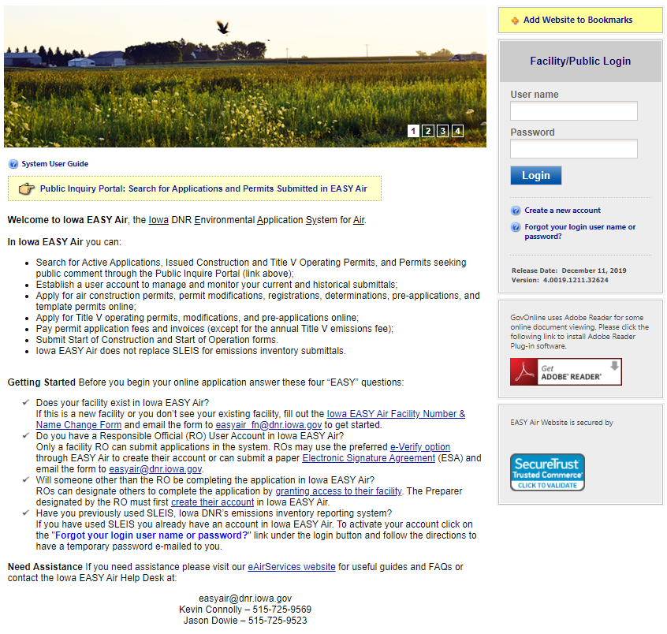
Figure 1 - Iowa EASY Air Website Login Page

Self-Registration
Click on “Create a new account” (Figure 2). Follow instructions 2.1 – 2.7 to register.
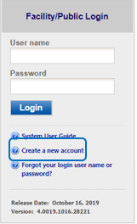
Figure 2 - Access Self – Registration

Fill in General Information
The registrant needs to complete all required fields in Figure 3 (denoted with a red asterisk). When finished, click the “Next>>” button
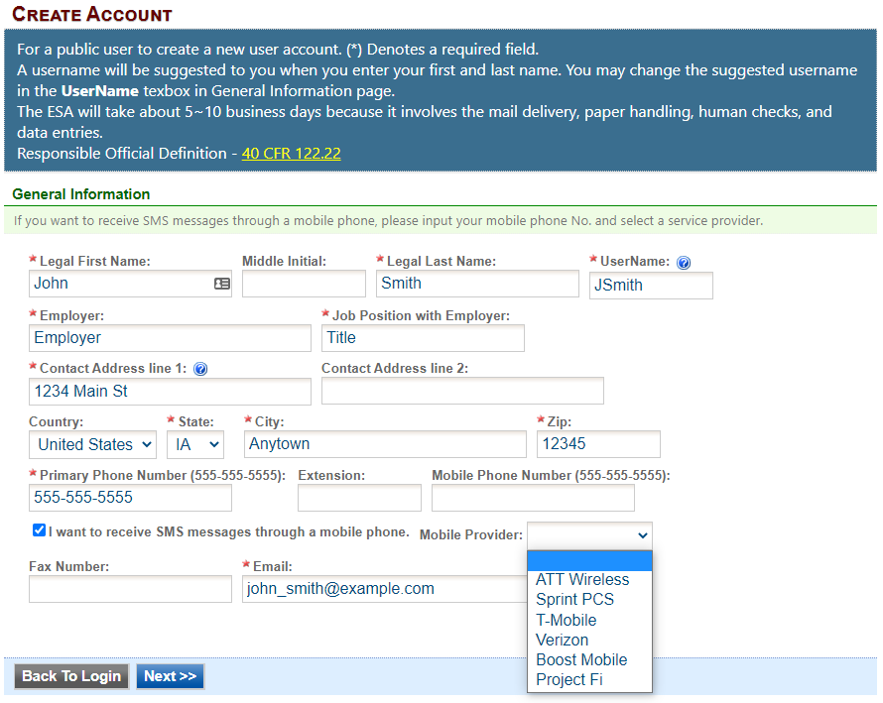
Figure 3 - Fill in General Information

Indicate Account Type
There are two user account types having different roles. An explanation of each of these roles is provided below (Table 1). The RO user role has additional privileges above the level of the Preparer.

Table 1 - Account Types in Iowa EASY Air
User Type | Account Privileges
Responsible Official (RO) | - Will be issued a PIN once their account privileges are approved by IOWA DNR  - Certify and submit an electronic data entry form in Iowa EASY Air  - Manage Preparers and Consultants  - View and prepare an electronic data entry form in Iowa EASY Air  - View submitted data in Iowa EASY Air  - Keep track of the status of submitted records
Preparer | - View and prepare an electronic data entry form in Iowa EASY Air  - View submitted data in Iowa EASY Air  - Keep track of the status of submitted records

If you are uncertain as to which role applies to you, contact the EASY Air Helpdesk at (515) 725-9569 or (515) 204-3749; or send your inquiry to easyair@dnr.iowa.gov.

Choose the “Responsible Official” user role (Figure 4). Select the Submittal Group(s) for the user (circled checkbox). This determines the types of applications the RO may submit to the Air Quality Bureau. Select either RO for Construction or RO for Title V or RO for both. When you make a choice in either Submittal Group, the Associated Facility List will open.
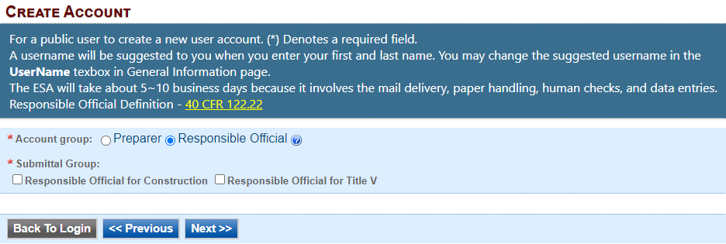
Figure 4 - Select Account and Submittal Type

Associate Facility or Facilities
As a RO (Responsible Official), the user may now associate a facility or facilities to his/her account (Figure 5).
If your facility is not found after searching, complete and submit the Facility Number & Name Change Form (DNR Form 542-1056) using the highlighted link in Figure 5.

Click on the “Associate Facility” button to launch a search window (Figure 6).
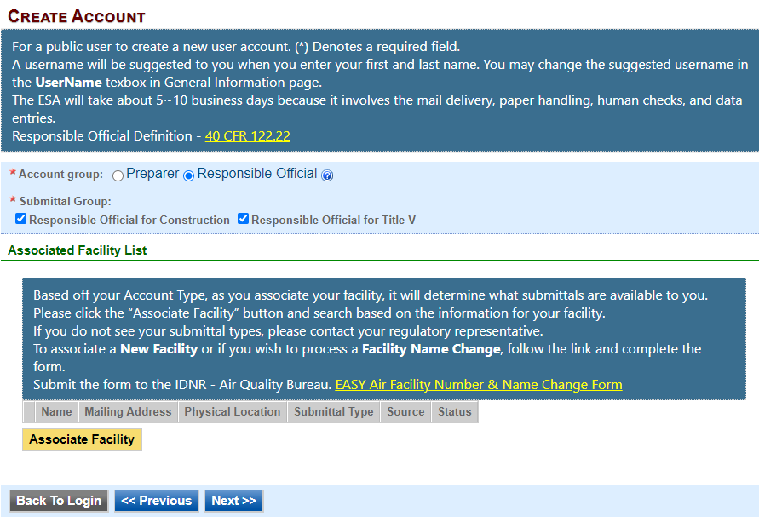
Figure 5 - Associate Facility

Figure 6 (below) displays on top of Figure 5. When associating a facility, the user can search the facility based on Facility Name, Address or Facility Number. Enter the search criteria and click the “Search” button.
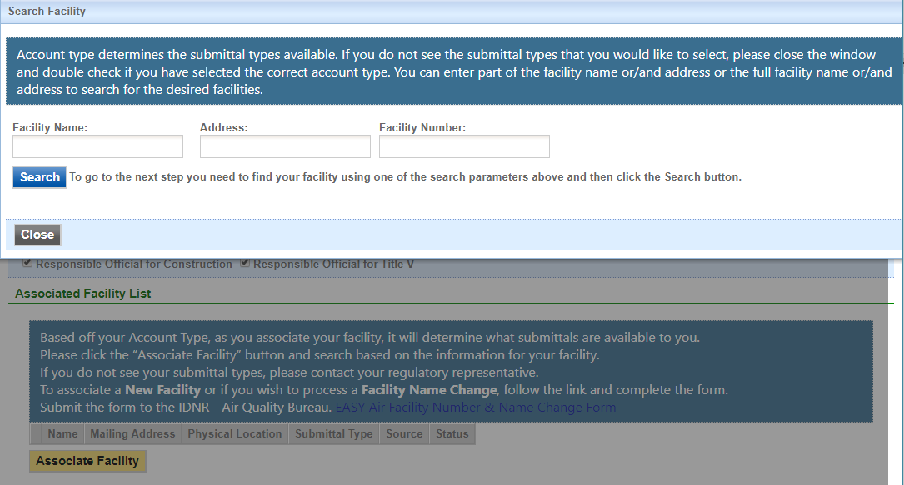
Figure 6 - Associate Facility Search
If your search returns no facilities, Figure 7 indicates the result and informs the user to contact the Iowa DNR Air Quality Bureau.
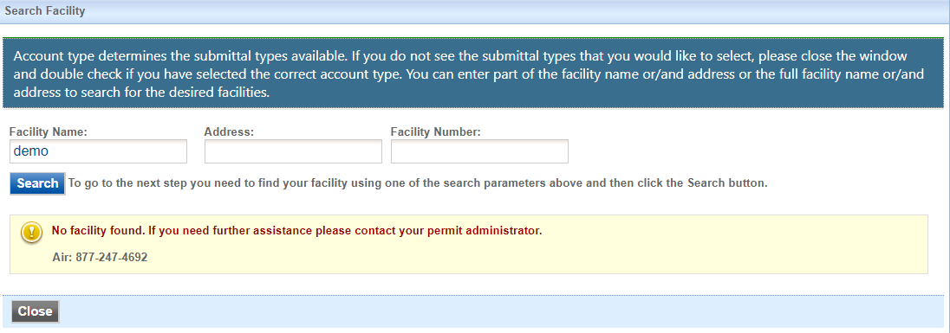
Figure 7 - Associate Facility Search - No Facilities Found

Iowa EASY AIR will retrieve facility list from IOWA DNR’s State Facility Database (Figure 8).
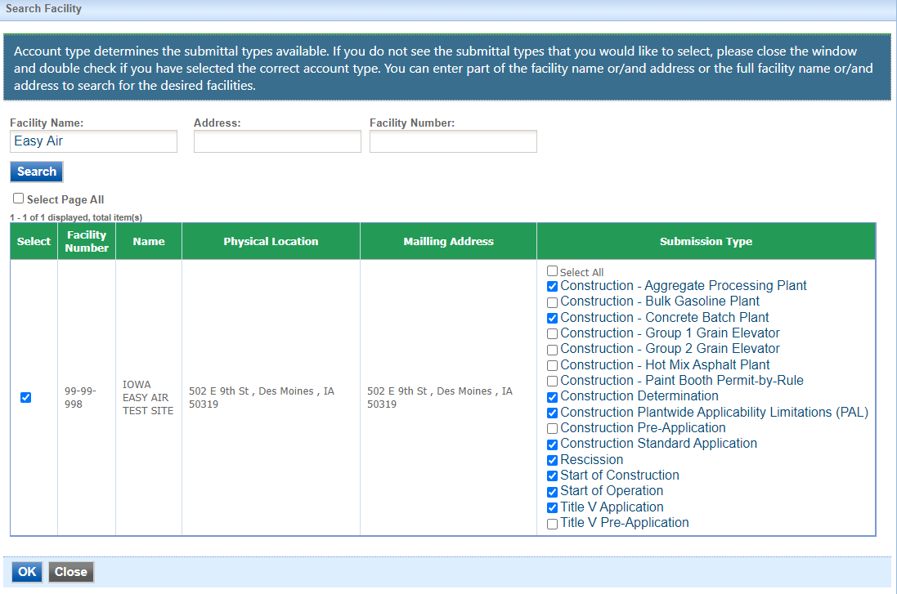
Select Your Facility

Select One or More Submission Types
Figure 8 - Select Facility from Facility List

Use the checkboxes to identify the facilities and types of applications (submissions) the RO will submit.
When all facilities and submission types have been selected, click the “OK” button. A confirmation window will appear at the top of the screen, click “OK.” Figure 8 will appear again, scroll to the bottom of the screen and click the “Close” button.

After clicking the "Close" button, the user will be returned to Figure 5, but will also show the facilities and permit submission types that were selected.
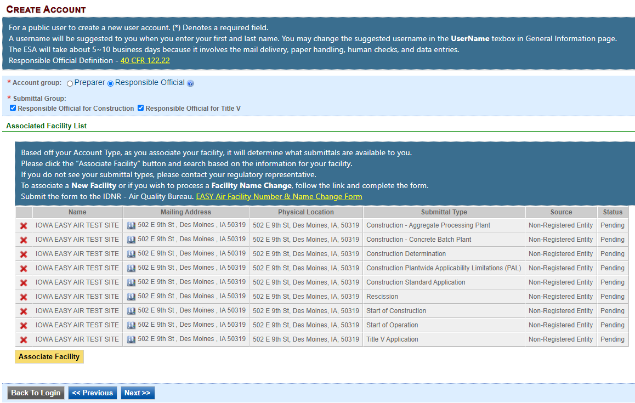
Figure 9 - Select Facility from Facility List

Click the “Next>>” button to continue the registration process in Section 2.4.

Select and answer Security Questions
The RO must assign answers to five security questions (Figure 10). These are required as part of the Certification process to submit a permit application through Iowa EASY Air. Click on “Next>>” when complete. The questions and answers may be changed in the user's profile page within EASY Air back in Figure 3.
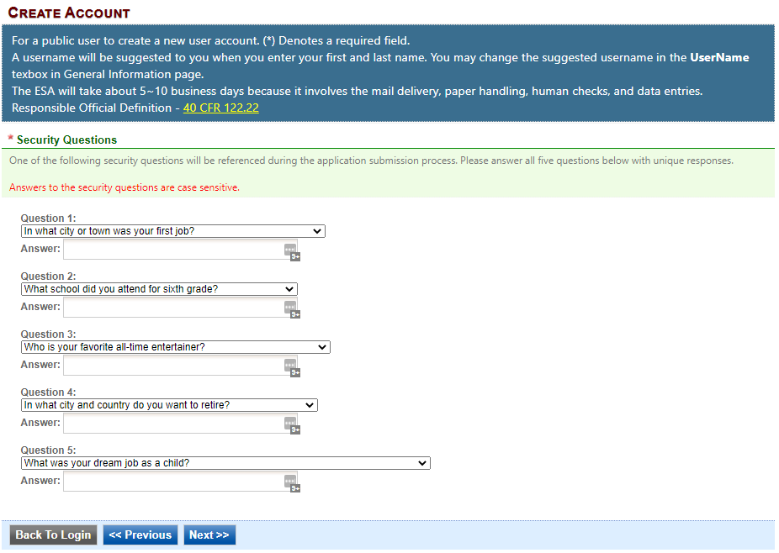
Figure 10 - Security Questions

Pass Picture Verification
Enter the characters you see in Figure 11 (case sensitive). The characters are drawn so that it is possible for a person to recognize them, but very difficult for a program to. This helps us prevent automated programs from creating large numbers of accounts and sending spam. Click on “Create Account.” You will receive an email with a temporary password to log in to EASY Air (Section 2.7, Figure 18).
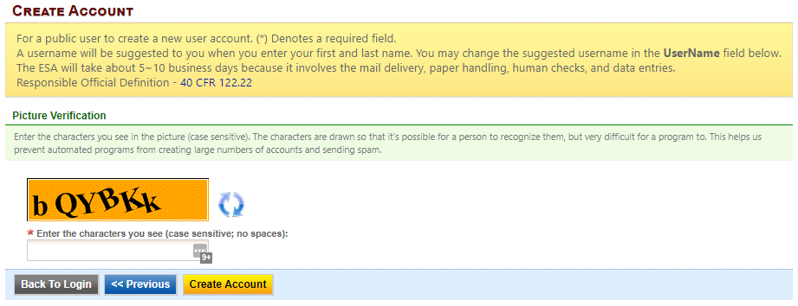
Figure 11 - Picture Verification

Select Identify Proofing Option
There are two types of user Identity Proofing in Iowa EASY Air shown in Figure 12. The e-Verify option uses a 3rd party identity verification company that is also used with submitting electronic records directly to the U.S. Environmental Protection Agency (EPA). The other method is by a paper Signature Agreement Form, validated by the Iowa DNR Air Quality Bureau. Both options are explained below.
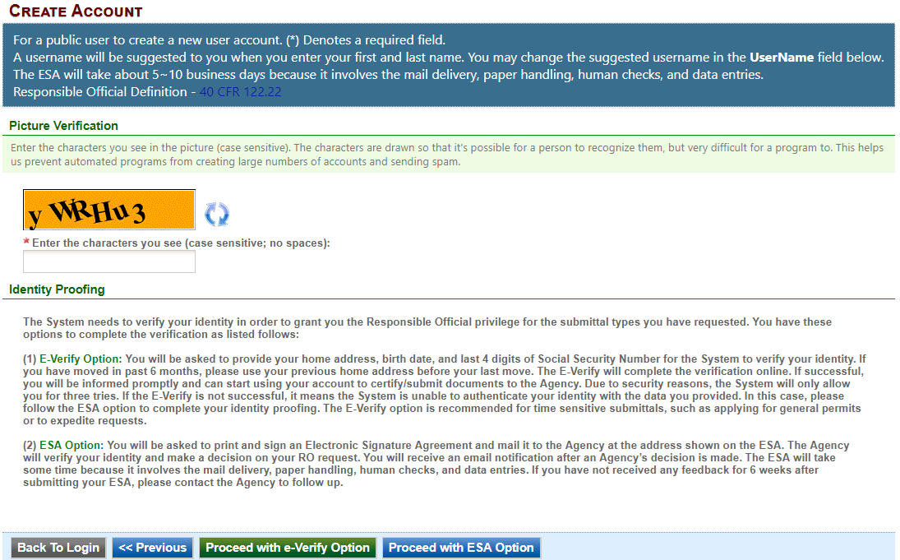
Figure 12 - User Verification Options

e-Verify Option
Click on the green “Proceed with e-Verify Option” button in Figure 12 to launch the connection to LexisNexis. Follow the instructions on screen to enter the validation information shown in Figure 13. Select the “Continue Registration Process” button when all information is completed.
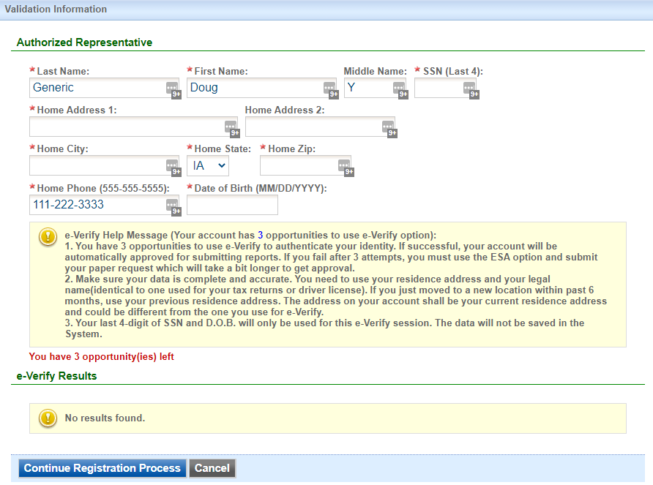
Figure 13 - e-Verify Option - Enter User Information

If the user passes all of the validation checks in the e-Verification process, click the “Save Profile Info” button to complete the verification. See Figure 14 for successful e-Verification in the User Account information.
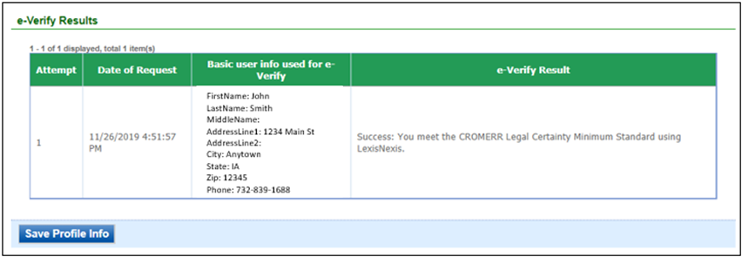
Figure 14 - e-Verify Successful

The e-Verify process makes all of your facilities and application (submittal) types active.
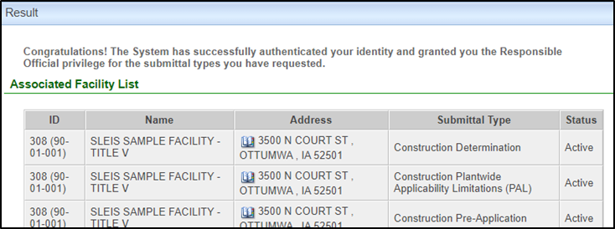
Figure 15 - e-Verify Completed

In the event that the eVerify option is unsuccessful (Figure 16) the user will be prompted to complete their account creation by using the Electronic Subscriber Agreement option shown in Figure 12.
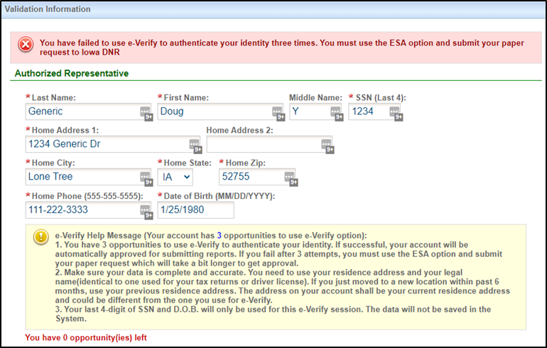
Figure 16 - e-Verify Unsuccessful

Electronic Signature Agreement (ESA) Option
Click on the blue “Proceed with ESA Option” button in Figure 12. This completes the Create Account process and presents Figure 17 to the user. The RO user can click the “Print the Subscriber Agreement” button to print to a printer or save as a PDF for Signature and mailing the ESA to the Air Quality Bureau.
Then click the “Back to Login” button to sign into Iowa EASY Air.
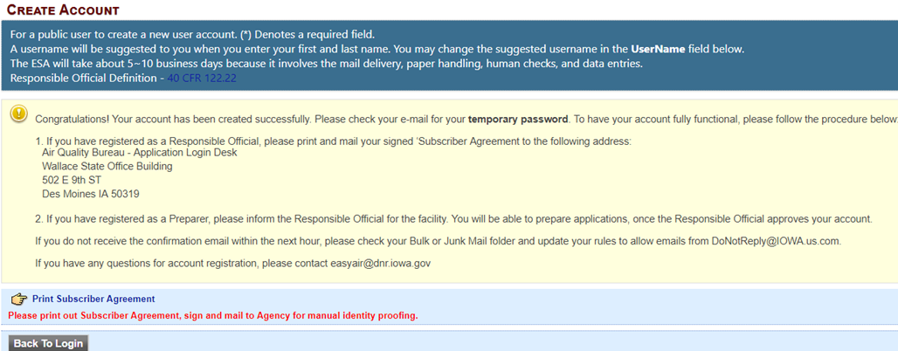
Figure 17 - Electronic Signature Agreement (ESA) Option

Receive email confirmation from Iowa EASY Air
Soon after you have successfully registered, you will receive an e-mail (Figure 18) from Iowa DNR that includes your Iowa EASY Air temporary password. This user ID and password are used one time to log into the Iowa EASY Air system for the first time.
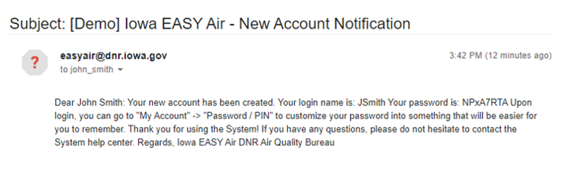
Figure 18 - Account Confirmation Email

Access Your Account Information
To view or make changes to your account information, log into Iowa EASY AIR (see Figure 1). Then click on the “My Account” tab (Figure 19). This page should be used to keep your Iowa EASY AIR account information up-to-date and change your password and manage your security questions. Users registered as a RO can use this section to request resetting their PIN. Figure 20 displays the information when the RO has successfully completed the e-Verify process.
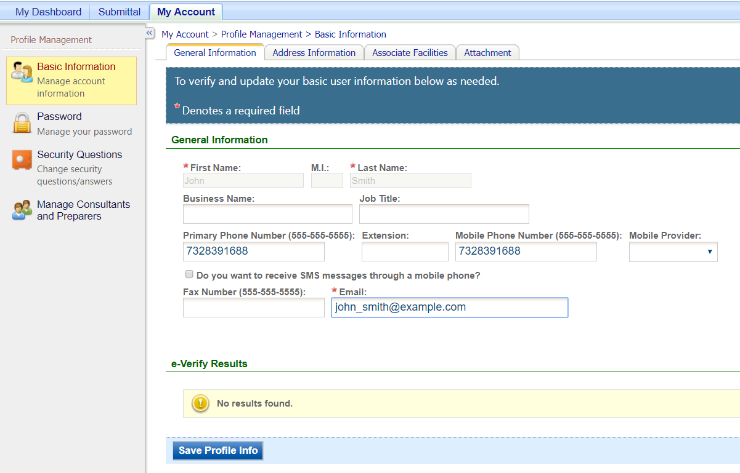
Figure 19 - Access “My Account”
If you successfully e-Verified your account, the bottom section of the Basic Information screen will show the success information (Figure 20). If you used the ESA method, the section will indicate "No results found."
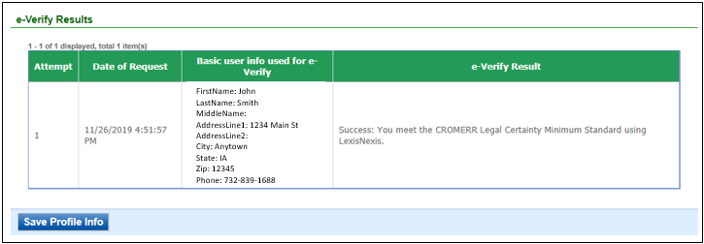
Figure 20 - Successful e-Verify Results

Request a New Facility Number or Process a Facility Change
When adding facilities to an applicant's user account (see Figure 5), either during new account creation (Section 2) or managing an existing account (Section 3), there are times when the search function does not return any records. One of the possibilities for this is that the facility does not exist in the database.

This may be due to a couple of reasons:
- The application is for a facility that is new or construction is planned in the future. It may be that the facility exists but has never had any permitting done and therefore also does not exist in the database.
- The facility has undergone an ownership change and the new name has not been entered in the database.

In both of these cases, the applicant will either need to request a facility number for the “new” facility, or request a facility name change.

When this occurs, the applicant should download the Iowa EASY Air Facility Number & Name Change Form (DNR Form 542-1056, shown in Section 5, for display only) from the Air Quality Bureau's EAirServices webpage or from within the Iowa EASY Air application.

If you have questions, please call the Iowa EASY Air Helpdesk
at (515) 725-9569 or (515) 204-3749.
Or, send an email to easyair@dnr.iowa.gov

Facility Number & Name Change Form (for display only)
EASY Air Facility Number & Name Change Form
A Facility Number (also called a Plant Number) is used to identify facilities across different Air Quality programs by county location. This number will be in the format of XX-YY-ZZZ, where XX the 2-digit County Number, YY is the 2-digit City Number within the County and ZZZ is the 3-digit count of facilities within the City. Portable Plants are given a PP-ZZZ-000 number. This number is generated and assigned by the DNR. | DNR Records Center ONLY
 | R. Series/Initials: | CON 10-1 /
 | Facility Number:
 | WK ACT/ Doc Code: |  | MS / CL

*Required Field
*1. Request Date:
*2. Contact Information:
First Name: |  |  |  |  |  |  |  |  |  |  |  |  |  |  | Last Name:
Position Title:
Mailing Address:
City Name: |  |  |  |  |  |  |  |  |  |  |  |  |  |  |  | State: |  |  |  |  |  | Zip Code:
Phone Number: |  |  |  |  |  |  |  |  |  |  |  |  | E-Mail Address:
*3. Facility Number Request: Is Facility Portable? Yes No |  |  |  |  |  |  |  |  |  |  |  |  |  |  |  |  |  |  |  |  | Choose one (a, b, c) from below
a. New Facility Number |  |  |  |  |  |  |  |  |  | b. Temporary Facility Number |  |  |  |  |  |  |  |  |  |  |  |  | c. Facility Name Change
*4. Comments: (Limited to 150 characters)
*5. New Facility Name:
*6. New or Existing (for Facility Name Change) Equipment Address:
*7. Facility City: |  |  |  |  |  |  |  |  |  |  |  |  |  |  |  |  |  |  |  | *8. Zip Code:
*9. County:
10. Identify any facilities, within five miles of the permitted facility, that this company owns and/or operates (include Facility number and name):
Facility No & Name |  |  |  |  |  |  |  |  |  |  | Facility No & Name |  |  |  |  |  |  |  |  |  |  |  |  | Facility No & Name
Please enter information for existing facility if requesting a Facility Name Change
11. Existing Facility Number (user format shown):
12. Existing Facility Name:

- Complete this form electronically (no hard copies). Save the original file.
- Please do not print and scan this form. Instead, E-Mail the completed original form to: EASY Air Number & Facility Change (easyair_fn@dnr.iowa.gov).

DNR RECORDS CENTER ONLY
New Facility Number: |  |  | Field Office Number:
Request Completion Date:
Records Updated by:
EASY Air Updated by:

Form Instructions

This form is used to request the following:
- New Facility Number
- Temporary Facility Number
- Process a Name Change for an Existing Facility

How to complete this form:

Navigation: Use the Down Arrow key or Tab key to move through the fields.

- Enter the date of your request.

- Complete the contact information section.

- Check one the following changes: a. New Facility Number, b. Temporary Facility Number, or c. Facility Name Change. Note: b. Temporary Facility Number should only be selected for determination requests associated with a planned facility. Identify if the plant is Portable: Yes or No. If Yes, skip fields 6-9 below.

- Use this field to provide details about the request, such as the source of information. For example, “This is a new facility that is planned to begin construction on [Insert Date]”, or "Our company is looking at expanding sometime in the future" or "The facility name has changed due to an ownership change that became effective on [Insert Date]."

- Provide the new facility name. For a name change, enter the new name.

6.-8. Provide the physical address for the proposed construction site or existing facility.

- Provide the name of the county where the facility will be or is currently located.

- Provide the facility number and facility name for any facilities this company owns and/or operates within 5 miles of the facility identified in items 5 through 9, or items 11 & 12.

Your requested Facility Number will be emailed to you.

If requesting a facility name or ownership change:

- Enter the existing facility number.

- Enter the existing facility name.

How to handle this form:

- Complete this form electronically (no hard copies). Save the original file, use any file name for your records.
- Please do not print and scan this form. Instead, E-mail the completed form to: EASY Air Number & Facility Change (easyair_fn@dnr.iowa.gov).
- On the e-mail subject line, indicate the type of facility change requested.
- E-mail questions regarding the status of your request to the email address above.

